Module 1

Practical 1
simple python program for Linear transformations and their elementary properties.

import numpy as np

# Define a linear transformation T(x) = A x
A = np.array([[2, 1],
[0, 3]])

def T(x):
return A @ x # Matrix multiplication

# Define vectors
u = np.array([1, 2])
v = np.array([3, 1])
c = 2

# Apply transformation
T_u = T(u)
T_v = T(v)

# Check additivity
left_add = T(u + v)
right_add = T_u + T_v

# Check homogeneity
left_hom = T(c * u)
right_hom = c * T_u

print("T(u) =", T_u)
print("T(v) =", T_v)

print("\nAdditivity check:")
print("T(u + v) =", left_add)
print("T(u) + T(v) =", right_add)

print("\nHomogeneity check:")
print("T(cu) =", left_hom)
print("cT(u) =", right_hom)

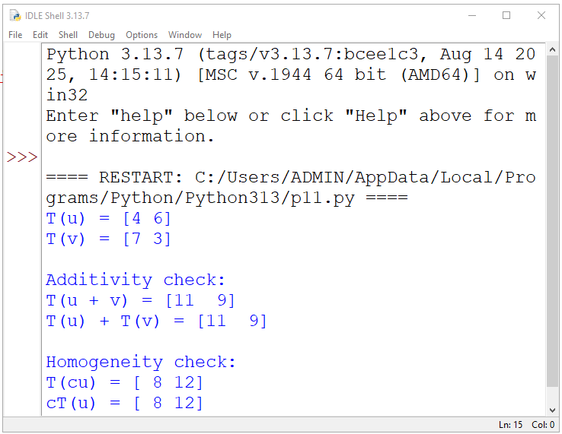

Practical 2
python program for Composite of linear transformations.

# First linear transformation
def T1(v):
x, y = v
return [2*x, 2*y]

# Second linear transformation
def T2(v):
x, y = v
return [x + y, x - y]

# Composite transformation T = T2 ∘ T1
def T_composite(v):
return T2(T1(v))

# Vector
v = [1, 3]

# Results
print("Vector v =", v)
print("T1(v) =", T1(v))
print("T2(T1(v)) =", T_composite(v))

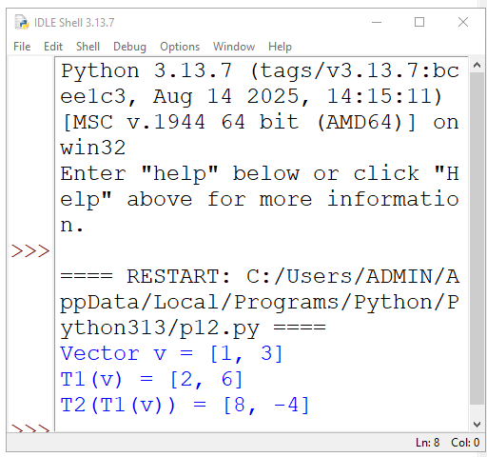

Practical 3
python program for Rank and nullity of a linear transformation with verification of rank-nullity
theorem.

import numpy as np

# Define transformation matrix A
A = np.array([[1, 2, 3],
[2, 4, 6]])

print("Matrix A:\n", A)

# Number of columns (dimension of domain)
n = A.shape[1]

# Rank of A
rank = np.linalg.matrix_rank(A)

# Nullity of A
nullity = n - rank

# Display results
print("\nRank of T =", rank)
print("Nullity of T =", nullity)

# Verify Rank–Nullity Theorem
print("\nVerification:")
print("Rank + Nullity =", rank + nullity)
print("Dimension of domain =", n)

if rank + nullity == n:
print("Rank–Nullity Theorem Verified")
else:
print("Rank–Nullity Theorem Not Verified")

